OS LAB 14
Name: Shaheryar Siddiqui ID:FA17-BECE-0023

Task1:
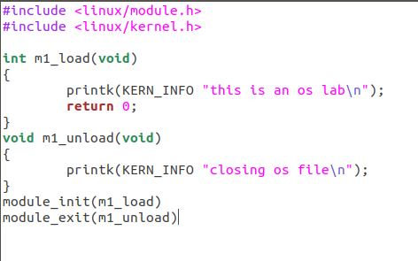

File 1:

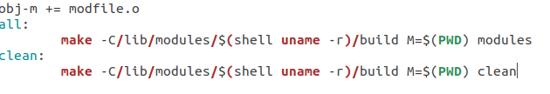

Output:
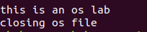

Task2:

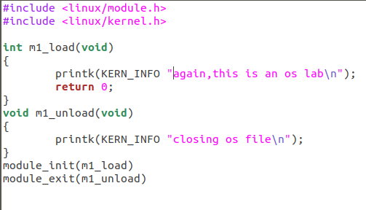
File 2:

Output:

